  - Install GCC on your computer and verify the installation by running gcc --version in your terminal or command prompt.

Steps:
Download and install GCC (using MinGW-w64 or MSYS2 on Windows).
Add the bin folder to the system PATH.
Open Command Prompt or Terminal.
Type: Bash
gcc --version
Expected Output:
gcc (MinGW-W64 GCC) 14.x.x
Copyright (C) Free Software Foundation, Inc.
...
2. Open VS Code or DevC++ and create a new file named hello.c. Write a C program that prints 'Hello, Instagram World!' to the console.

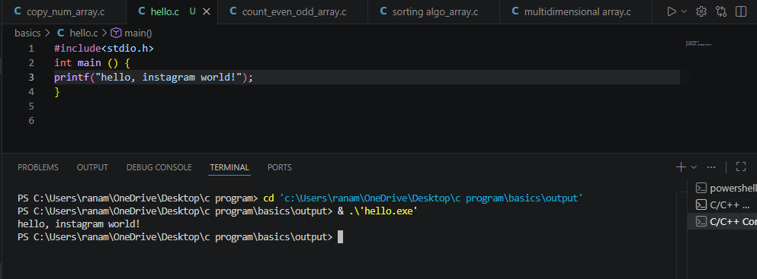

3. Identify and label the header, main function, and return statement in your hello.c program using comments.
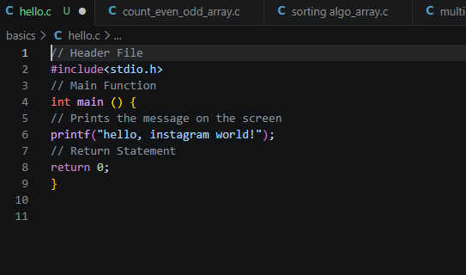

4. Compile your hello.c file using the GCC command line (gcc hello.c -o hello) and run the output file to display the message in your terminal.<br><br><em><strong>Hint:</strong> On Windows, the output file will be hello.exe; on Linux/Mac, it will be hello.
